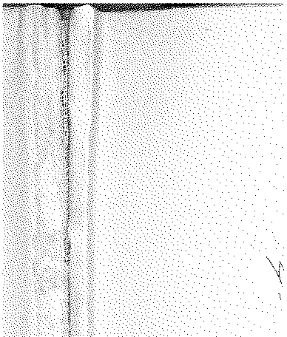

# Annual Vol ume of

TH E LAW S



# of Western N igeria

1962

## containin g

the Laws of Western Nigeria

and subsidiary legisla tion made thereunder



LOS ANGELES COUNTY

LAW LIBRARY

### B 497

* + - 1. **267 of 1962**

### The Local Government Law (Cap. 68)

THE CONTROL OF DRUMMING ADOPTIVE BYE-LAWS, 1956 MAKUN (SHAGAMU) LOCAL COUNCIL

**DATE OF COMMENCEMENT: 20TI-I SEPTEMBER, 1962**

**Notice is hereby given that in exercise of the pO\vers conferred upon the** Makun (Shagamu) Local Council by sections 83 (2) and 276 of the Local Goverrnnent Law, Cap. 68, the Makun (Shagamu) Local Council in accord­ ance with section 83 (3) (a) of the said Law has resolved at its meeting held on the 14th day of October, 1961 that the First and Third Schedules to the Makun (Shagamu) Local Council Control of Drumming Adoptive Bye-laws published as W.R.L.N. 100 of 1959 be amended as follows:

* + - * 1. by adding to the Fi rst Schedule the words-­

**''Aro Sekere"**

* + - * 1. by adding to the Third Schedule the words-

**Amendment to W.R.L.N 100 of 1959.**

##### nDescri'ptitm of Droms

Aro

**Sekere** ...

##### Period

**For any period benveen 6 a.m. to 6 a.m. For any period between 6 a.m. to 6 a.m.**

##### Fees

*s d*

20 0

20 O"

DATFD this 3rd day of August, 1962.

J. *Ow.* OGUNNOWO,

***Chainnan,***

*Committee of Management,*

*M akun* (*Shagamu) Local Council*

M. A. 0SINSANYA,

_ ***Secretary,***

#### Committee of Management ,

*Makun ( Shagamu) Local Council*

